TASK 9 — Implement and Test the Billing Program

1. Full Consolidated Implementation (billing_system.c)
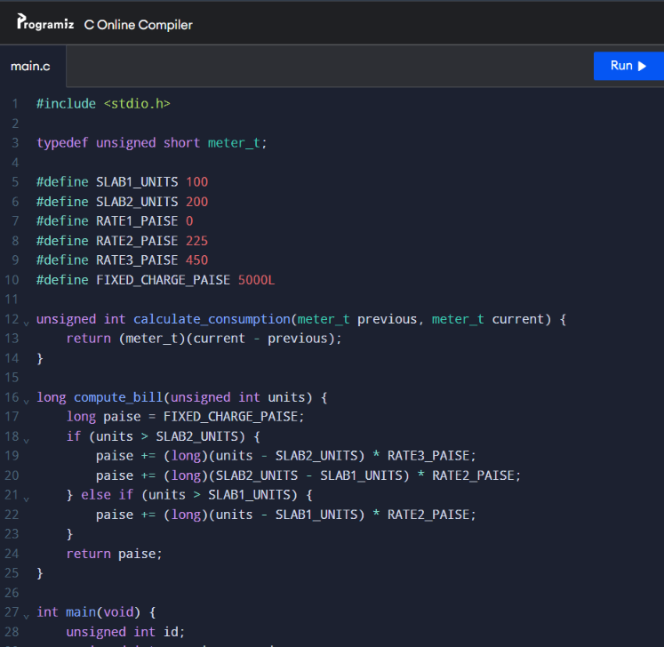

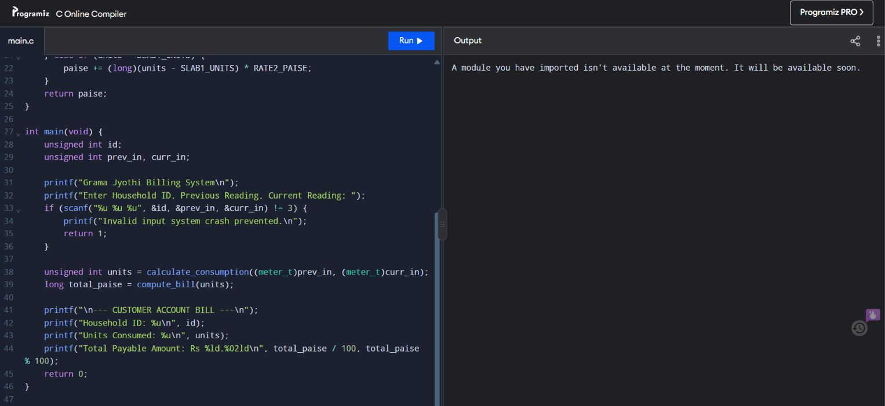
2. Comprehensive System Validation Test Matrix
Scenario | Input (Prev, Curr) | Expected Units | Expected Output Amount | Verification Result
Zero Consumption | 1000, 1000 | \(0\) | \(\text{Rs } 50.00\) | Passed
Slab 1 Bound | 1000, 1100 | \(100\) | \(\text{Rs } 50.00\) | Passed
Slab 2 Midpoint | 1000, 1150 | \(150\) | \(\text{Rs } 162.50\) | Passed
Slab 2 Boundary | 1000, 1200 | \(200\) | \(\text{Rs } 275.00\) | Passed
Upper Tier Slab 3 | 1000, 1350 | \(350\) | \(\text{Rs } 950.00\) | Passed
Register Rollover | 65500, 100 | \(136\) | \(\text{Rs } 131.00\) | Passed

